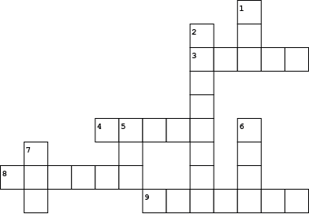

|  |  |  |  |
| --- | --- | --- | --- |
| **Across** | | **Down** | |
|  | |  | |
| **3.** |  | **1.** |  |
| **4.** |  | **2.** |  |
| **8.** |  | **5.** |  |
| **9.** |  | **6.** |  |
|  |  | **7.** |  |